Deployment in Azure portal
Steps in VS Code:
- Create a folder/directory on a local drive (for example, D:\ or E:).
- Open Visual Studio Code (VS Code), click File → Open Folder, and select the folder you created.
- Once the folder is opened in VS Code, create and activate a virtual environment inside the project directory.
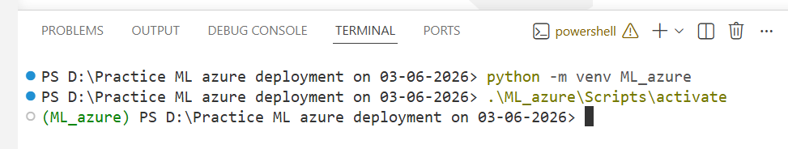
- Create the required folders and files according to your project requirements, following an appropriate folder and file hierarchy.
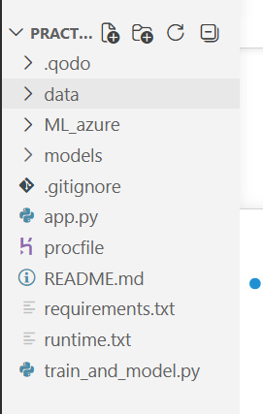
Why is it needed?
When your application is deployed, the server needs to know:
Which file to run?
Which command to execute?
Which process to start?
The Procfile provides this information.

Example for Streamlit
web: streamlit run app.py --server.port=$PORT --server.address=0.0.0.0
Meaning:
Part | Description
web | Web process
streamlit run app.py | Run Streamlit app
--server.port=$PORT | Use platform-assigned port
--server.address=0.0.0.0 | Allow external access

Example for Flask
web: gunicorn app:app

Example for FastAPI
web: uvicorn main:app --host 0.0.0.0 --port $PORT

- Now, add the required code to the corresponding files as per your project requirements.
- Train.py
import os
import numpy as np
import pandas as pd
import joblib
from sklearn.datasets import load_iris
from sklearn.linear_model import LogisticRegression
from sklearn.ensemble import RandomForestClassifier
from sklearn.model_selection import train_test_split
#Load data
#iris = load_iris()
#X, y = iris.data, iris.target
file_path = os.path.join('data', 'Iris.csv')
print(file_path)
df = pd.read_csv(file_path)
df = df.drop(columns=['Id'], axis=1)
print(df.head())
X = df.drop('Species', axis=1)
y = df['Species']
X_train, X_test, y_train, y_test = train_test_split(X, y, test_size=0.2)
#Train model
rf = RandomForestClassifier()
rf.fit(X, y)
print(rf.score(X, y))
#save model
joblib.dump(rf, 'models/rf_iris.pkl')
print('Model saved successfully')

- app.py
import streamlit as st
import numpy as np
import joblib
# Load model
model = joblib.load("models/rf_iris.pkl")
st.title("🌸 Iris Flower Classification App")
st.write("Enter the flower measurements:")
# Input fields
sepal_length = st.slider("Sepal Length", 4.0, 8.0, 5.0)
sepal_width = st.slider("Sepal Width", 2.0, 4.5, 3.0)
petal_length = st.slider("Petal Length", 1.0, 7.0, 4.0)
petal_width = st.slider("Petal Width", 0.1, 2.5, 1.0)
# Prediction
if st.button("Predict"):
input_data = np.array([[sepal_length, sepal_width, petal_length, petal_width]])
prediction = model.predict(input_data)
classes = ["Setosa", "Versicolor", "Virginica"]
st.success(f"Predicted Flower: {prediction[0]}")

